PROJECT DOCUMENTATION
Sales, Revenue & Profit Performance Analysis

Tool Used: Microsoft Excel + Power Pivot
Dataset: Project Data 2

Aghe Marvellous
Track: Excel Data Track

PROJECT OVERVIEW
The goal of this project was to analyze:
- Revenue performance
- Profit performance
- Profit Margin
- Regional trends (Africa focus)
- Product performance (Top & Bottom 5)
- Country-level profitability
- Year-over-Year (YoY) performance
The final output was a professional dashboard built using:
- Pivot Tables
- Power Pivot (Data Model + DAX Measures)
- Slicers
- Conditional Formatting
DATA UNDERSTANDING
The dataset contained:
- Region
- Country
- Item Type
- Sales Channel
- Order Priority
- Order Date
- Units Sold
- Unit Price
- Unit Cost
- Total Revenue
- Total Cost
- Total Profit
It covered multiple regions globally across several years.
DATA CLEANING PROCESS
Before analysis, we ensured the dataset was accurate and reliable.
3.1 Handling Missing Values
The following fields had missing values:
- Total Profit – 1 cell
- Total Revenue – 1 cell
- Unit Price – 1 cell
- Order Priority – 1 cell
- Item Type – 2 cells
- Country – 3 cells

Numerical Fields (Recalculated, NOT replaced with 0)
We used business logic instead of inserting 0.
Total Revenue Formula:
= Units Sold × Unit Price
Total Profit Formula:
= Total Revenue - Total Cost
OR
= Units Sold × (Unit Price - Unit Cost)
Unit Price Formula:
= Total Revenue ÷ Units Sold
We recalculated instead of guessing.
Categorical Fields (Replaced with "Unknown")
For:
- Order Priority
- Item Type
- Country
We replaced missing values with:
"Unknown"
Reason:
- Preserves row integrity
- Avoids deleting transactions
- Keeps pivot totals accurate
Later, “Unknown” was excluded from dashboard visuals to maintain professionalism.
DATA VALIDATION
We verified:
- Revenue = Units × Price
- Profit = Revenue − Cost
- No duplicates in Order ID
- Correct data types (Date, Number, Currency)
LOOKUP TASKS (XLOOKUP & VLOOKUP)
We performed lookup operations to retrieve specific order details.
Using XLOOKUP (Preferred Method)
To find Order Date for Order ID 100674521:
=XLOOKUP(A85, G:G, F:F, "Not Found", 0)
Where:
- A85 = Order ID reference
- G:G = Order ID column
- F:F = Order Date column
To find Country:
=XLOOKUP(A85, F:F, B:B, "Not Found", 0)
Alternative (INDEX + MATCH)
=INDEX(E:E, MATCH(A85, F:F, 0))
Used when data type mismatch occurred.
ROFIT CATEGORIZATION & CONDITIONAL FORMATTING
We created a Profit Category column.
Formula Used:
=IF(N2<=500,"Minimum Profit",
IF(N2<=1000000,"Average Profit",
"High Profit"))
Conditional Formatting Rules:
Category | Rule | Color
Minimum | Between 0–500 | Red
Average | 501–1,000,000 | Yellow
High | Above 1,000,000 | Green
This visually separated low and high-value transactions.
KPI CALCULATIONS
We did NOT average row-level margins.
Correct method:
Profit Margin = SUM(Total Profit) ÷ SUM(Total Revenue)
In Excel:
=SUM(N:N)/SUM(L:L)
This ensures weighted margin.
POWER PIVOT IMPLEMENTATION
We used Power Pivot to create dynamic measures.
Step 1: Load Data to Data Model
Insert → Pivot Table →
Add this data to the Data Model
Step 2: Create Date Table
Calendar =
ADDCOLUMNS(
CALENDAR(MIN(Dataset[Order Date]), MAX(Dataset[Order Date])),
"Year", YEAR([Date]),
"Month", FORMAT([Date], "MMM"),
"Month No", MONTH([Date])
)
Relationship:
Calendar[Date] → Dataset[Order Date]
DAX MEASURES CREATED
Base Measures
Total Revenue
Total Revenue := SUM(Dataset[Total Revenue])
Total Profit
Total Profit := SUM(Dataset[Total Profit])
Profit Margin
Profit Margin :=
DIVIDE([Total Profit], [Total Revenue])
PREVIOUS YEAR (PY) CALCULATIONS
Revenue PY
Revenue PY :=
CALCULATE(
[Total Revenue],
SAMEPERIODLASTYEAR(Calendar[Date])
)
Revenue YoY %
Revenue YoY % :=
DIVIDE(
[Total Revenue] - [Revenue PY],
[Revenue PY]
)
Profit PY
Profit PY :=
CALCULATE(
[Total Profit],
SAMEPERIODLASTYEAR(Calendar[Date])
)
Profit YoY %
Profit YoY % :=
DIVIDE(
[Total Profit] - [Profit PY],
[Profit PY]
)
PROFIT MARGIN YoY
We calculated:
Profit Margin PY :=
CALCULATE(
[Profit Margin],
SAMEPERIODLASTYEAR(Calendar[Date])
)
Margin Difference:
Profit Margin YoY :=
[Profit Margin] - [Profit Margin PY]
Note: If Profit Margin YoY shows 0%, it may be due to:
- Single year selected
- Slicer filtering only one year
- No previous year in context
TREND ANALYSIS (Africa Focus)
We created Pivot:
Rows → Year
Columns → Region
Values → Total Revenue
Inserted Line Chart.
This showed revenue trend across:
- Sub-Saharan Africa
- Middle East & North Africa
PRODUCT PERFORMANCE
We created:
- Top 5 products by Revenue
- Bottom 5 products by Revenue
Sorted descending and ascending in Pivot.
Top 5 COUNTRY-LEVEL PROFIT ANALYSIS
Rows → Country
Values → Total Profit
Sorted descending
Displayed Top 5
SLICERS USED
We used:
- Sales Channel
- Order Date
These controlled all pivot visuals via Report Connections.
WHAT WE EXCLUDED
We intentionally avoided:
- Averaging profit margins per order
- Using 0 for missing values
- Showing “Unknown” in dashboard visuals
- Using raw column formulas for YoY
- Overloading dashboard with unnecessary slicers
DASHBOARD DESIGN STRUCTURE
Top Section:
- Revenue KPI
- Profit KPI
- Profit Margin KPI
- PY comparison
- YoY indicators
Middle:
- Revenue Trend (Africa focus)
- Regional Performance Comparison
Bottom:
- Country-Level Profit
- Top 5 Products
- Bottom 5 Products
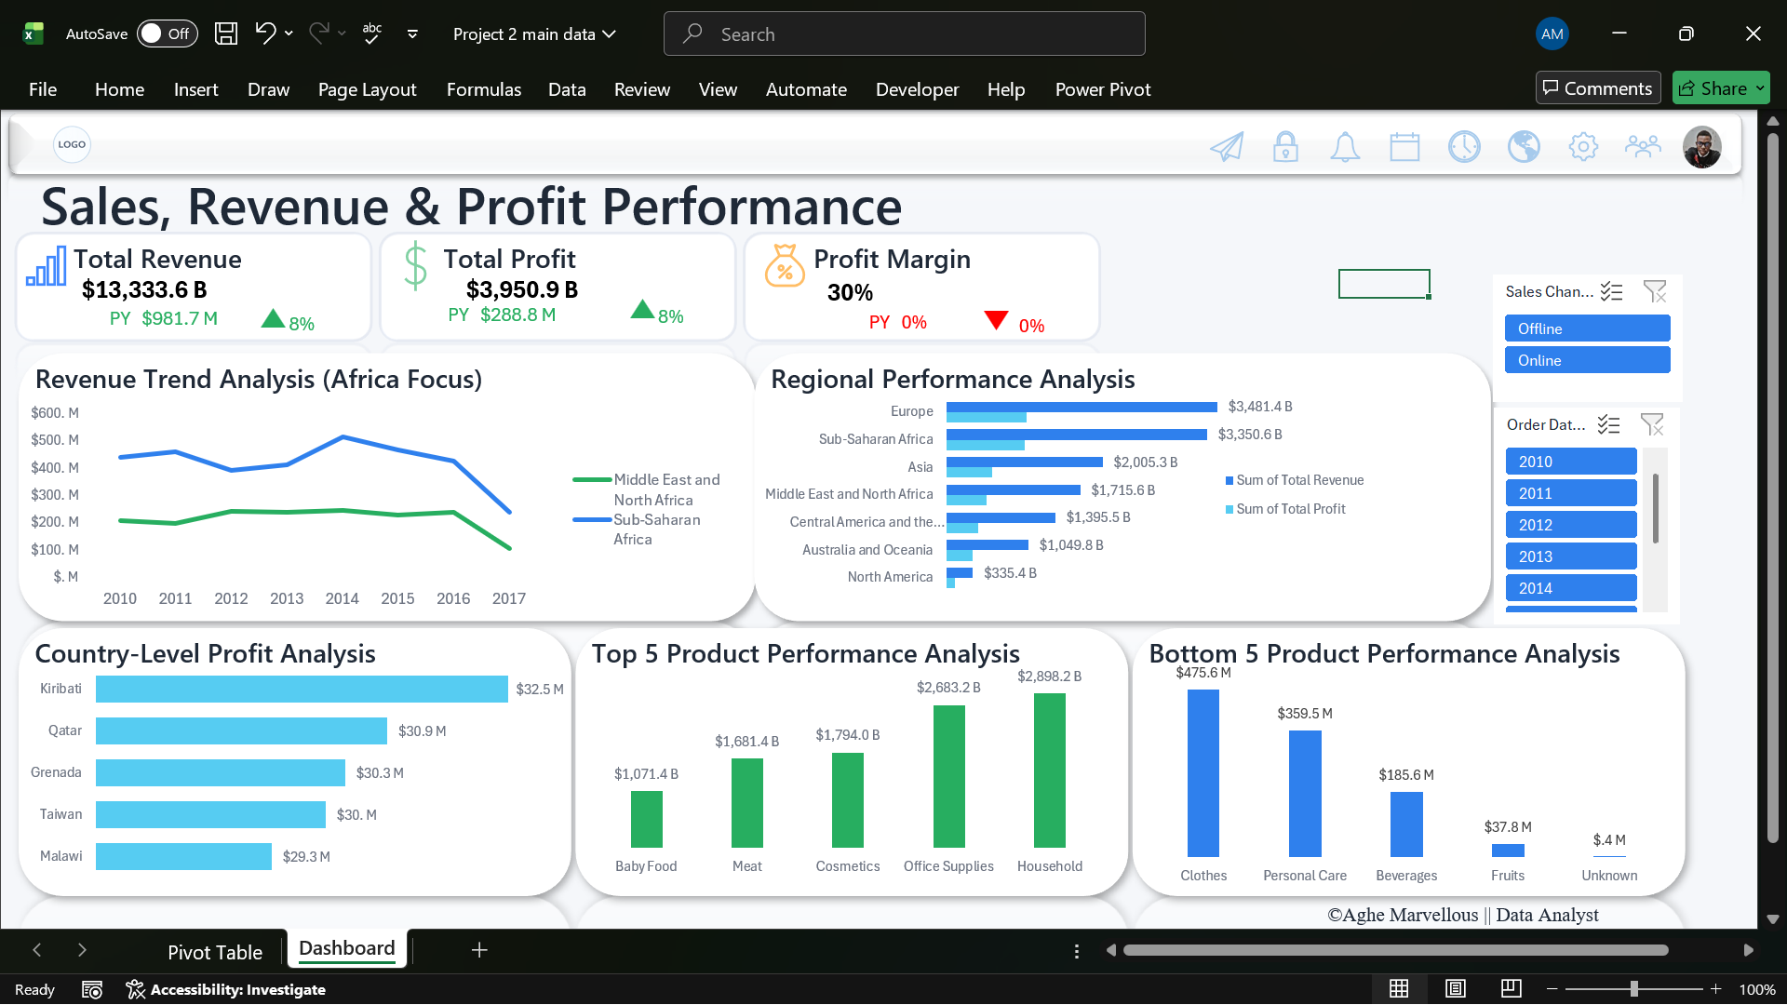
FINAL INSIGHTS
The dashboard enables:
- Performance tracking over time
- Regional profitability comparison
- Product performance identification
- Channel performance comparison
- Margin efficiency monitoring
PROJECT LEARNING OUTCOMES
This project demonstrates:
- Data cleaning skills
- Lookup proficiency (XLOOKUP, INDEX/MATCH)
- Conditional formatting logic
- Weighted KPI calculation
- Power Pivot & DAX competency
- Time intelligence (PY, YoY)
- Dashboard storytelling
FINAL SUMMARY
This project followed a structured analytical approach:
- Data cleaning
- Data validation
- Lookup analysis
- Categorization & formatting
- KPI construction
- Power Pivot modeling
- Time intelligence implementation
- Insight-driven dashboard creation

Strategic Recommendations
Based on the complete analysis — from data cleaning and validation to PowerPivot modeling and dashboard insights — the following strategic recommendations are proposed:
  - Strengthen Data Governance and Validation Processes
During the analysis, several missing values were identified (Total Profit, Total Revenue, Unit Price, Item Type, Country, and Order Priority). While these were carefully handled using recalculation and standardized placeholders like "Unknown," their presence highlights the need for improved data controls.
Recommendation:
- Implement mandatory field validation for financial and geographic data.
- Introduce structured dropdown selections for categorical variables (Item Type, Country, Order Priority).
- Enforce automated checks for blank financial values before reporting.
Why this matters:
Accurate KPIs such as Profit Margin and YoY growth depend entirely on clean data. Stronger validation reduces reporting risk and improves decision reliability.
  - Prioritize High-Performing Regions for Expansion
The regional performance analysis showed that certain regions consistently generate higher revenue and stronger profitability.
Recommendation:
- Allocate more marketing and distribution resources to top-performing regions.
- Conduct deeper segmentation analysis within these regions to identify high-demand product categories.
- Consider expansion strategies in similar markets with comparable characteristics.
Strategic Impact:
Investing where performance is already strong increases return on investment and accelerates growth.
  - Improve Performance in Underperforming Regions
The dashboard highlighted regional revenue and profit disparities.
Recommendation:
- Investigate cost structure differences in lower-performing regions.
- Review pricing strategies and supply chain efficiency.
- Assess whether low profit is due to high costs, discounting, or low sales volume.
Strategic Impact:
Optimizing weaker regions can significantly increase overall company profitability without necessarily increasing sales volume.

